Potential resources to be included on CD COP page
Title Page
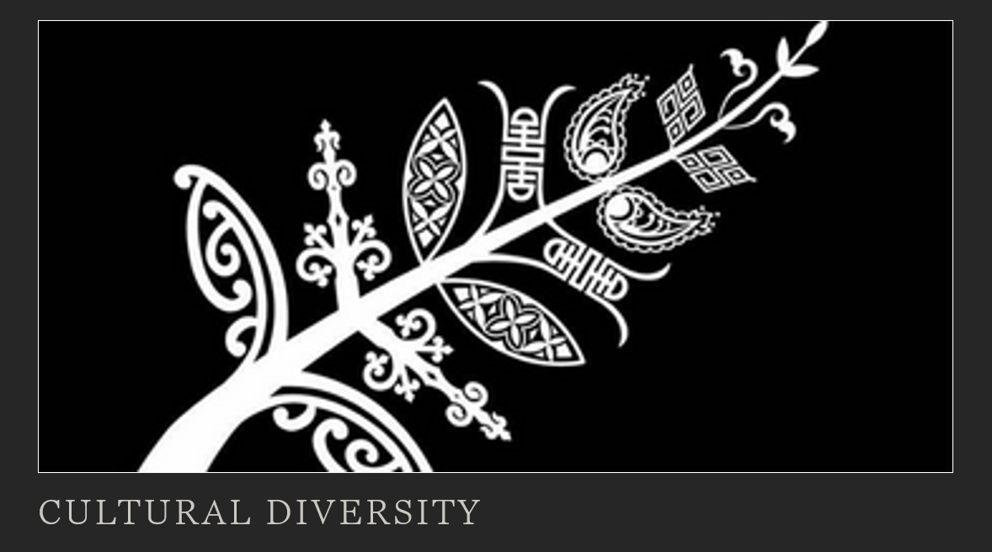

Contents Page:
- Introduction
- Ministry Documents/Strategies
- Māori
- Pacific
- Other Cultures
- Spirituality
- Student Voice Tools

1.Introduction
Treaty of Waitangi
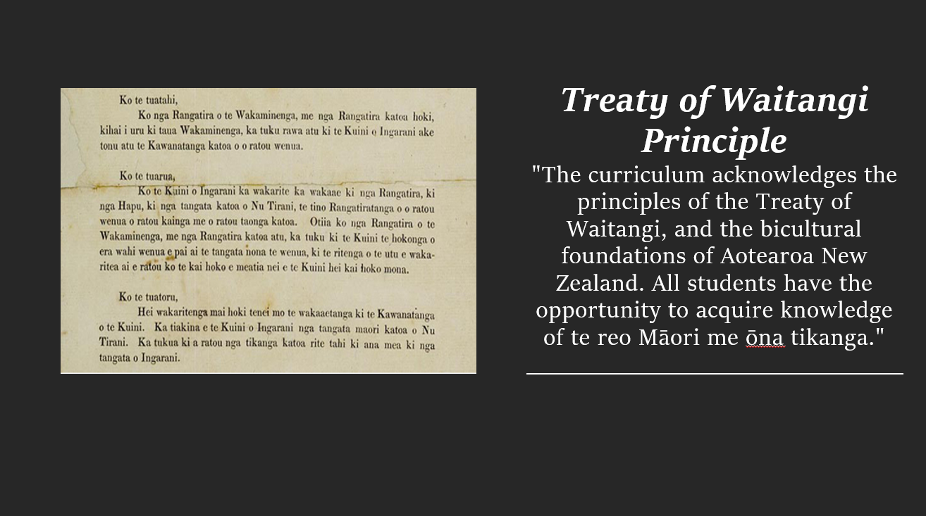
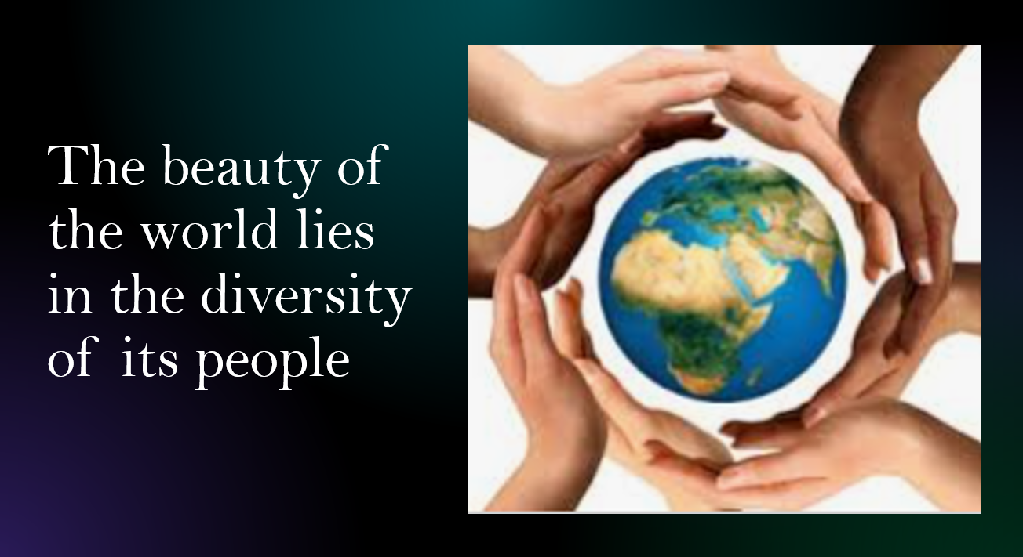

2.Ministry Documents/Strategies
Tātaiako

Ka Hikitia
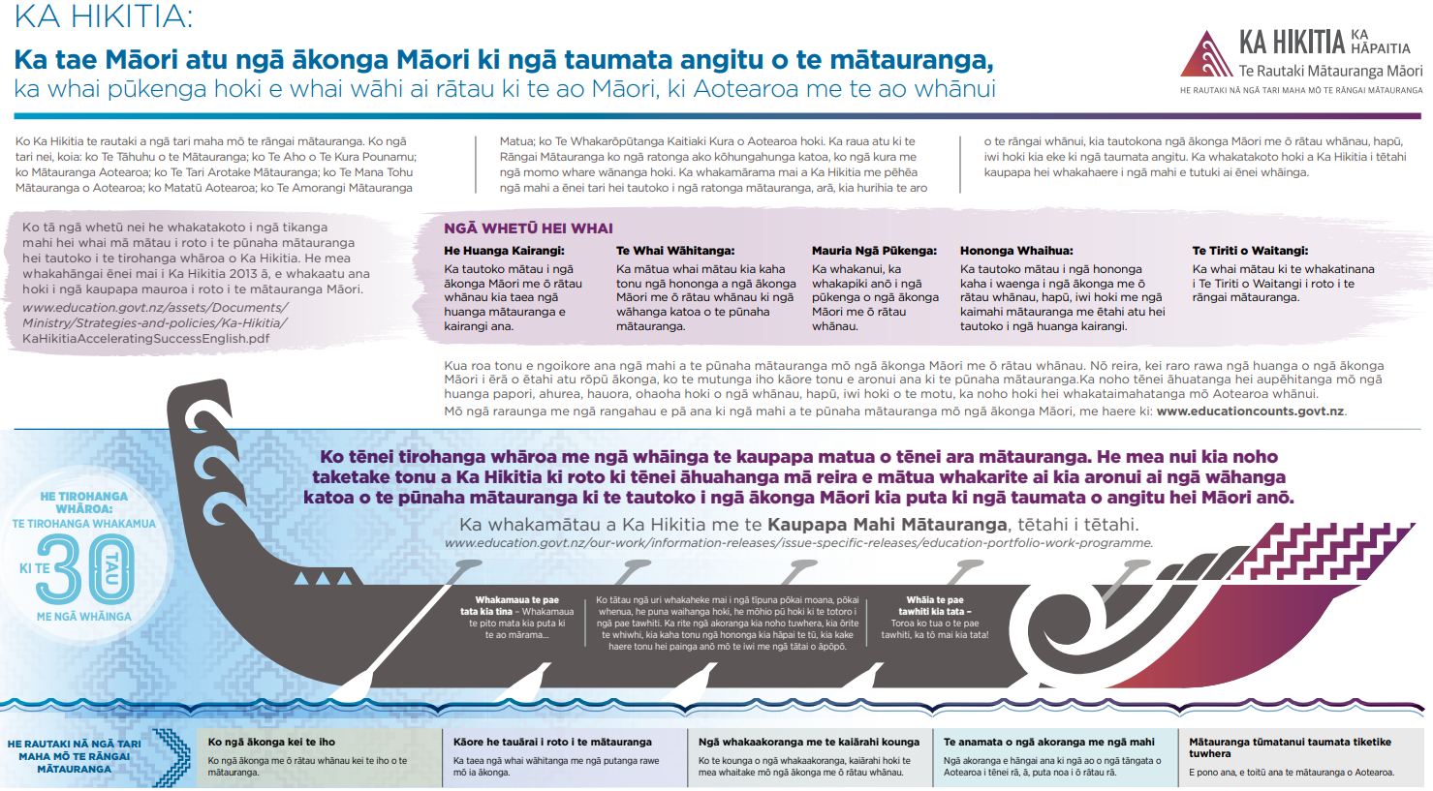
Tapasā
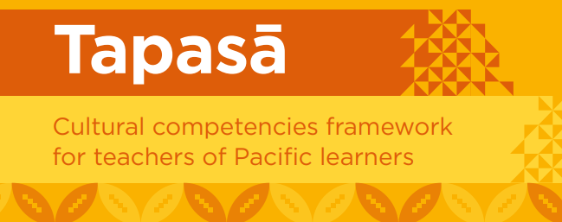

Action Plan for Pacific Education 2020-2030
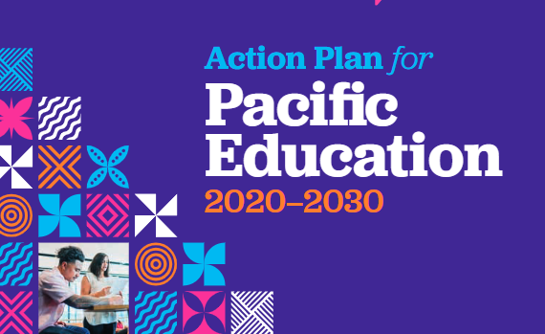

Tau Mai Te Reo
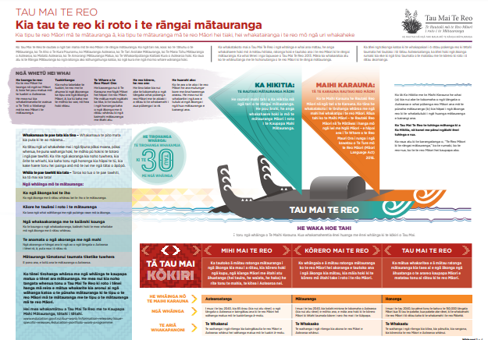

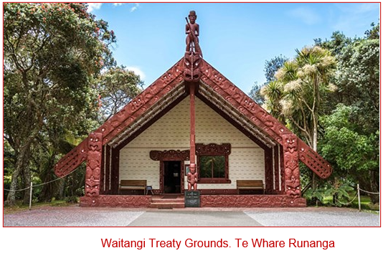
3.Māori

Whakataukī
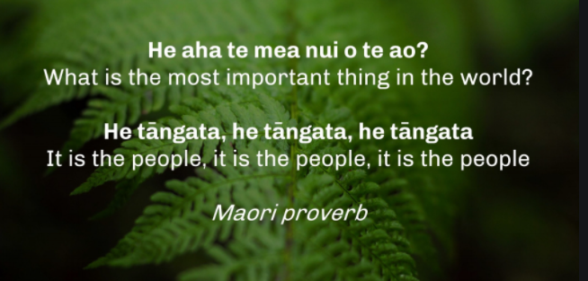
Kaumatua page
Videos/vimeos

Tuakana Teina(YouTube Clip)
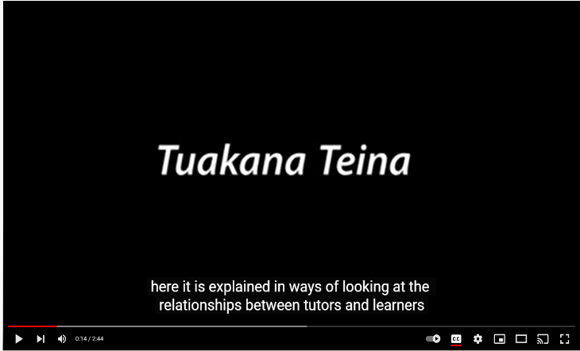

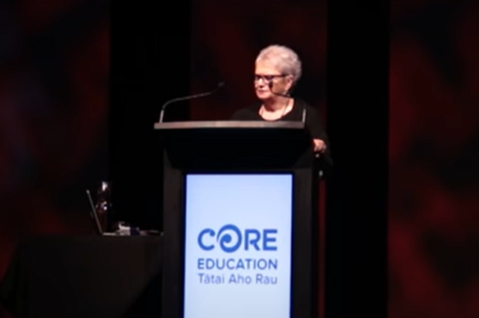
Colouring in the White Spaces: Dr Anne Milne (YouTube Clip)

Professor Colleen Ward - A Multicultural nation in a Bicultural context
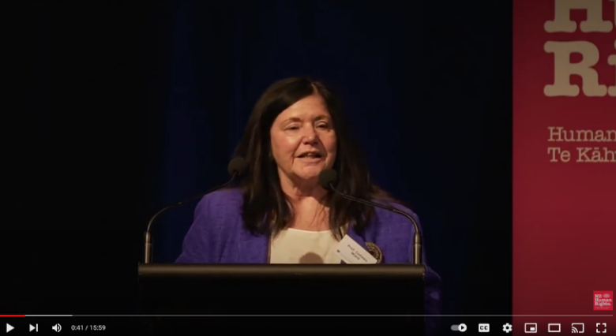

Articles/professional readings
My Pepeha is My World
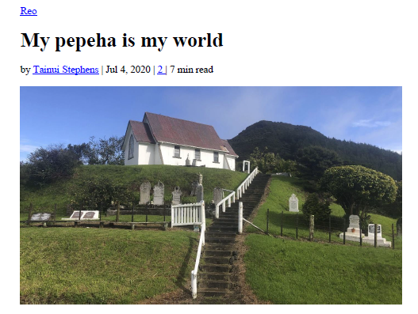

Te Pikinga ki Runga: Raising Possibilities (2012)
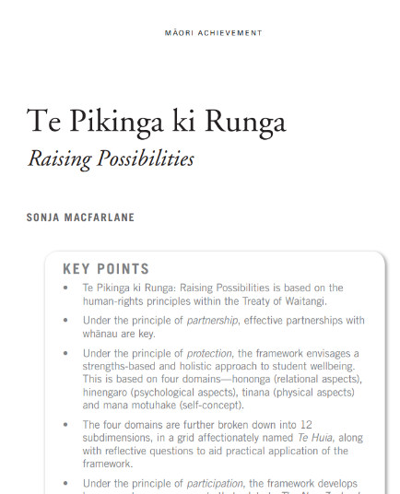

The Rule of Law, BiCulturalism and Multiculturalism(Speech)
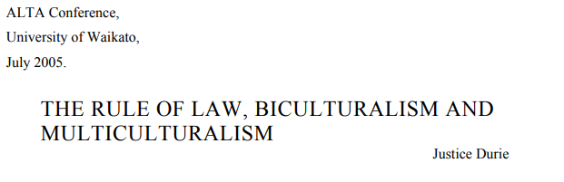
PowerPoints/Google slides/Prezis
Summary of Culturally Responsive Pedagogy
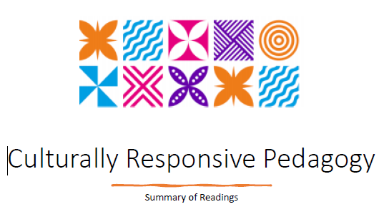

Summary of Tātaiako
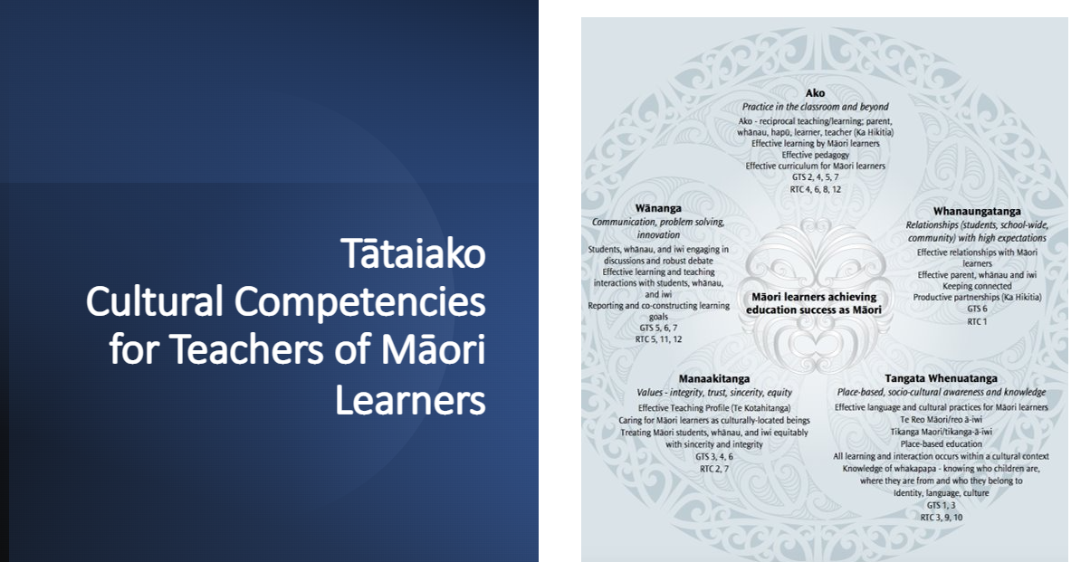
Summary and Critical Reflections on Connecting with Māori Communities: Whānau, Hapū and Iwi - Mere Berryman & Theresa Ford 2014(PowerPoint)
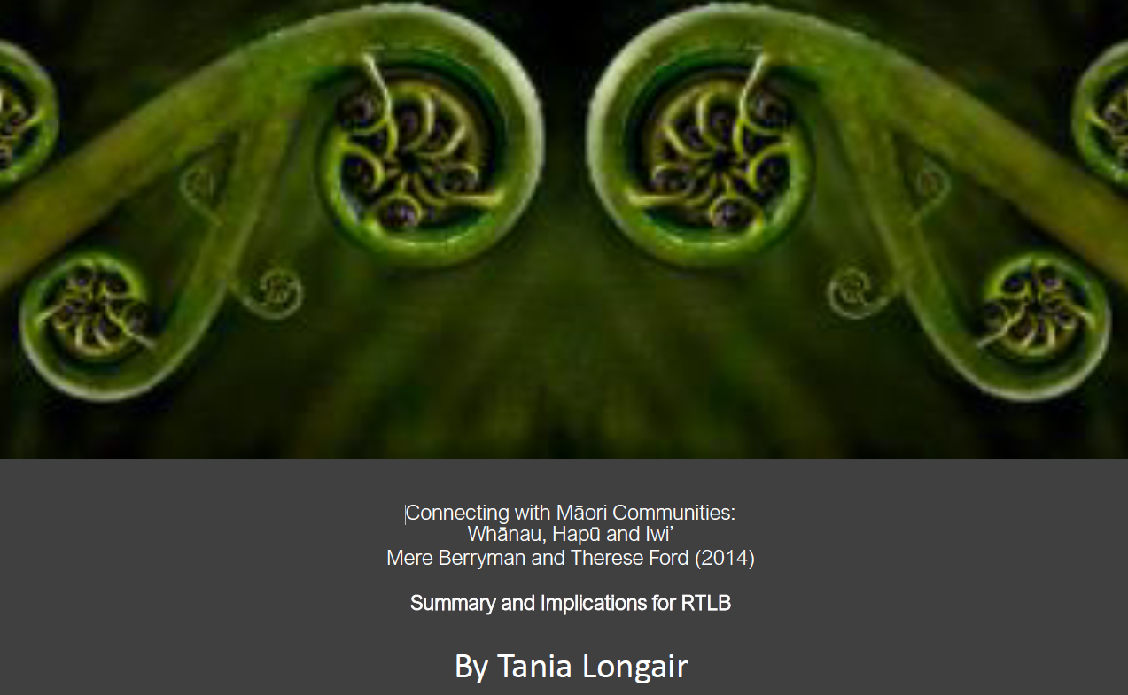
Educationally Powerful Connections with Whānau – Summary and Implications for Practice
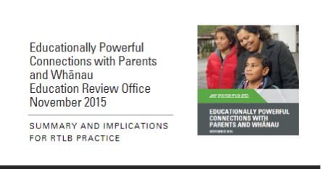
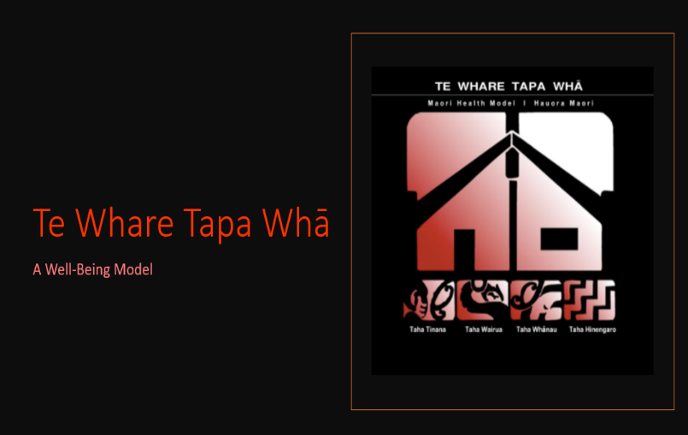
Te Whare Tapa Whā Workshop Presentation

Te Whare Tapa Whā Prezi (Link)
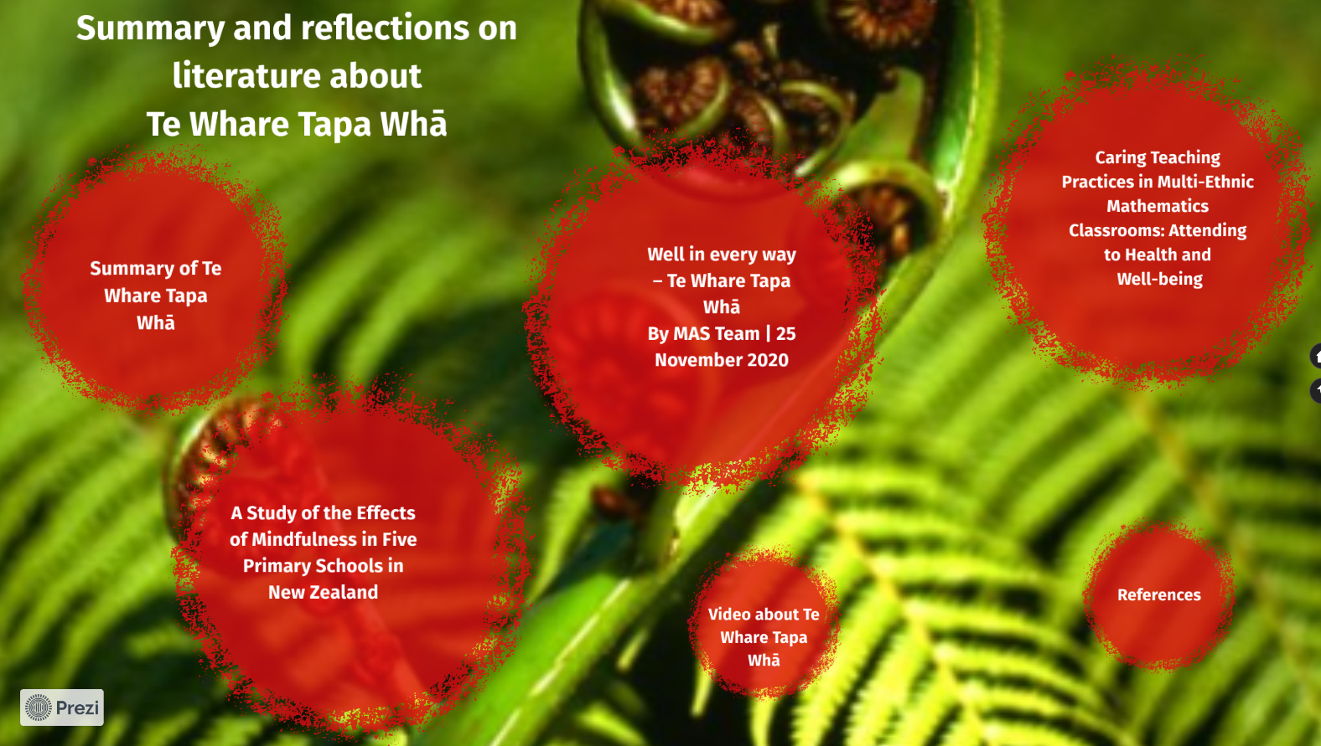
Te Pikinga ki Runga Prezi presentation (Link)
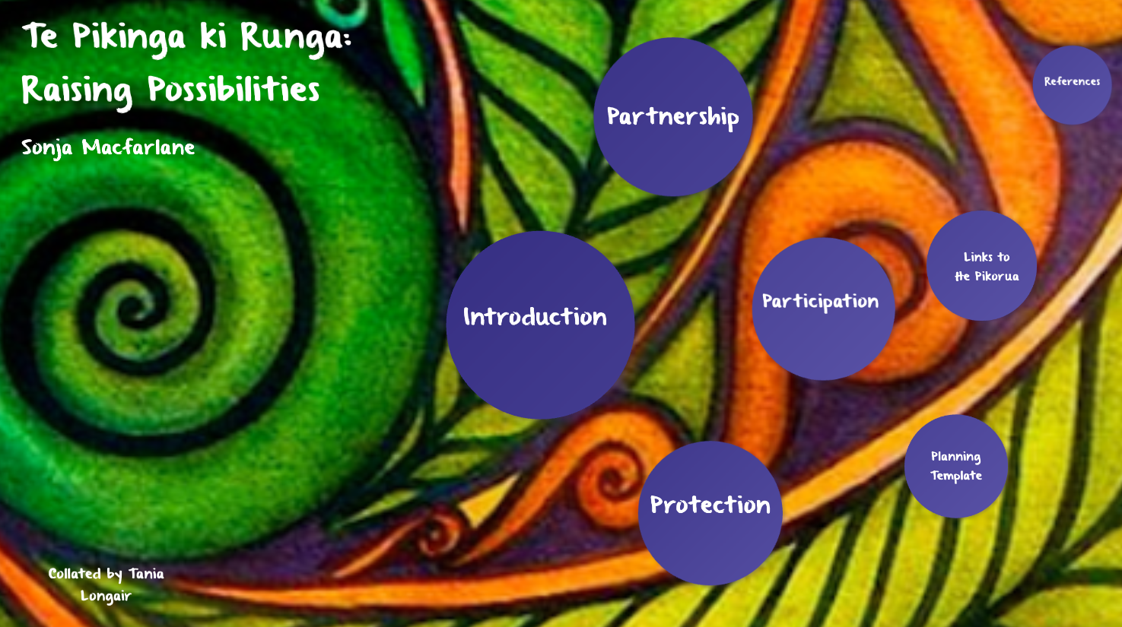
Te Pikinga ki Runga (SlideShare presentation by Special Education)
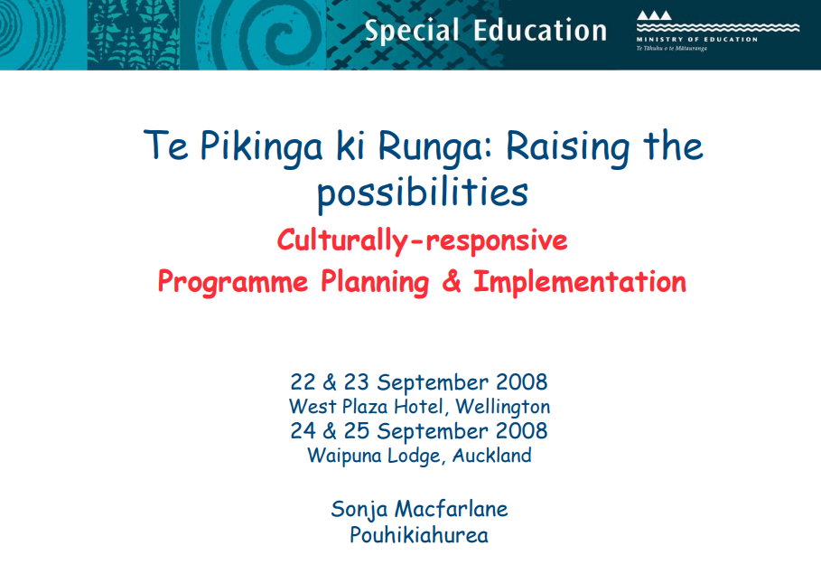
The Hikairo Schema: A Cultural Review Tool (SlideShare)
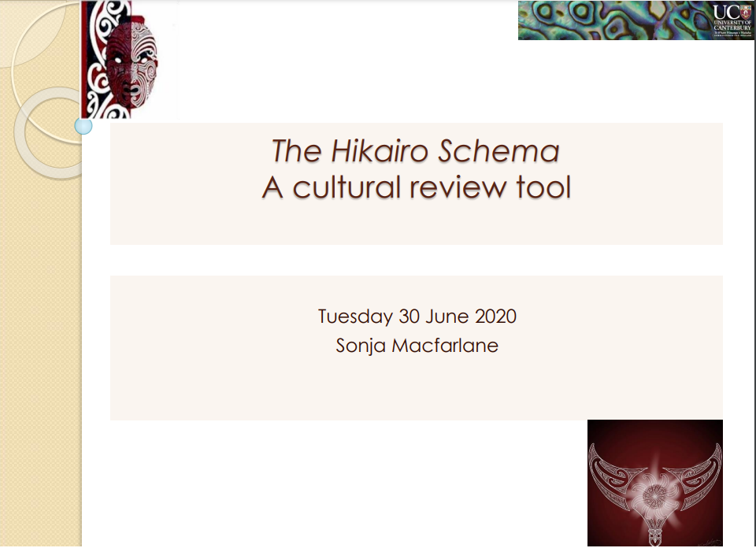
Biculturalism and Multiculturalism (Powerpoint)
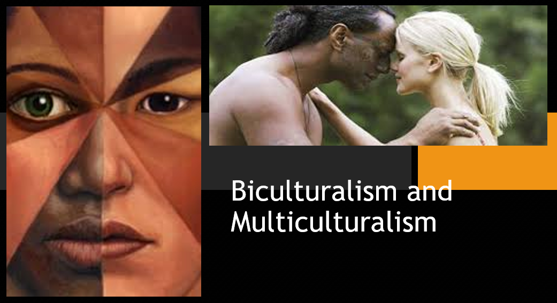
Tataiako & Tapasa Implications for Inclusive RTLB Practice
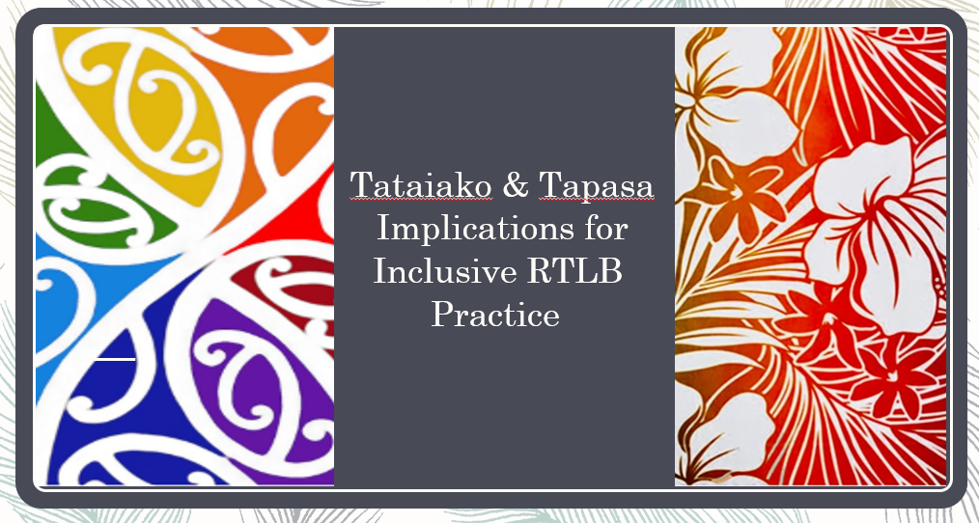
Culturally Responsive Teaching (E-Book)
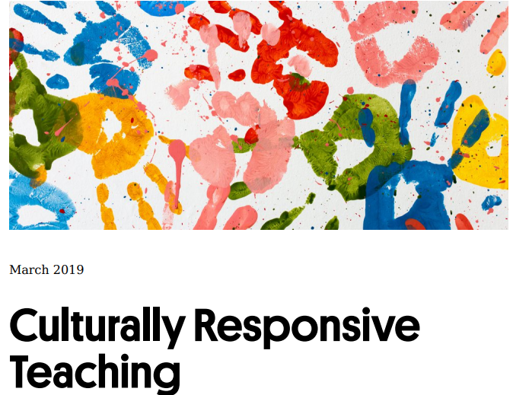

Cultural Iceberg (Template)
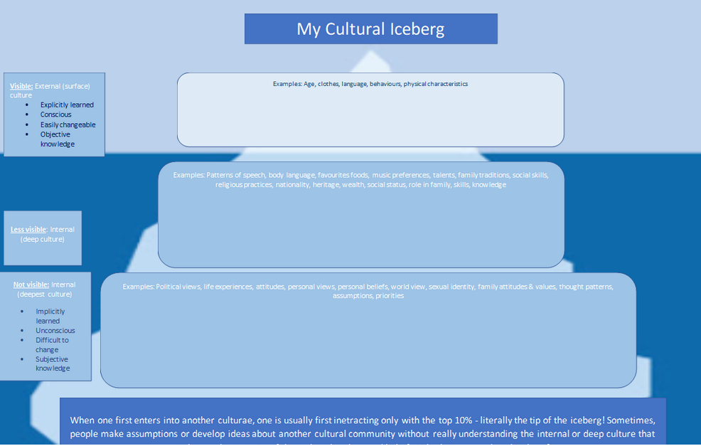

Tuakana Teina - PowerPoint
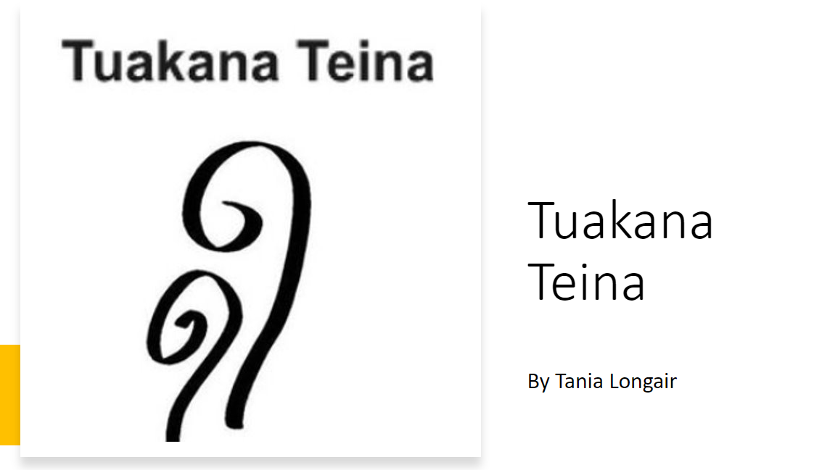

Reflections on the Tuakana Teina Approach
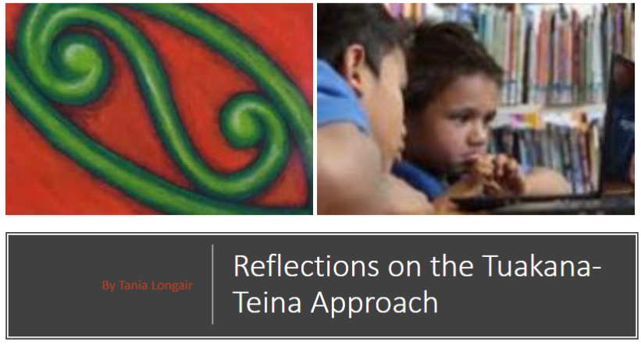

Unconscious Bias(PowerPoint)
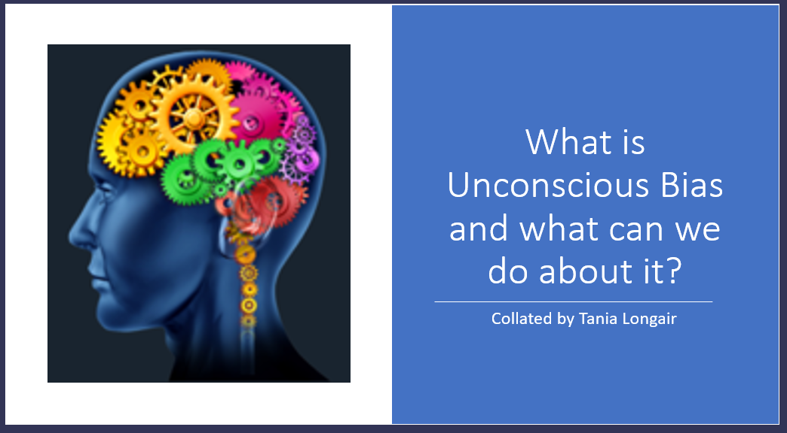

Culture and Power(Prezi)
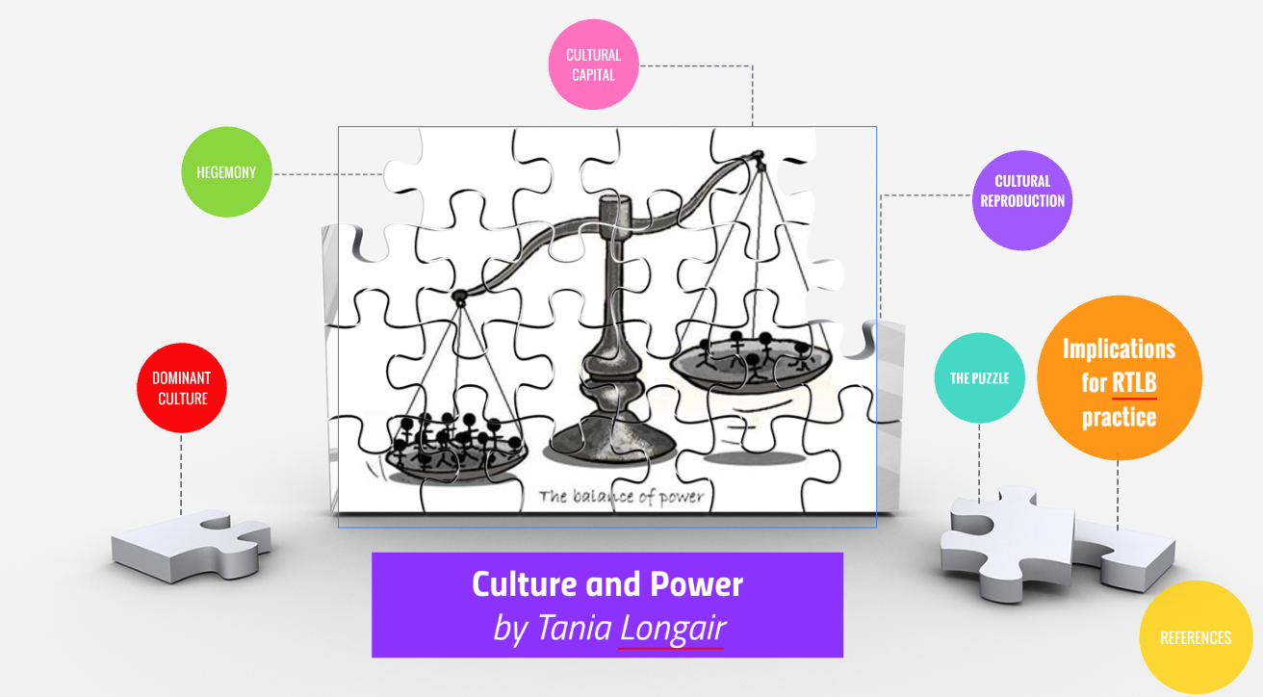
Mindful Reflection as a Process for Developing Culturally Responsive Practice
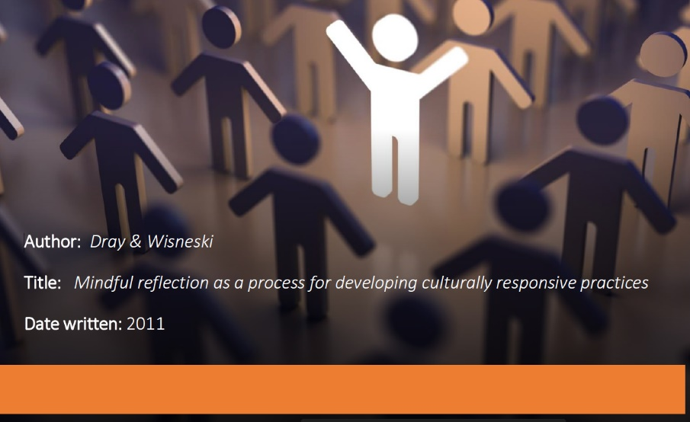

Subject specific resources
Literacy
Peer Writing PowerPoint Workshop Presentation
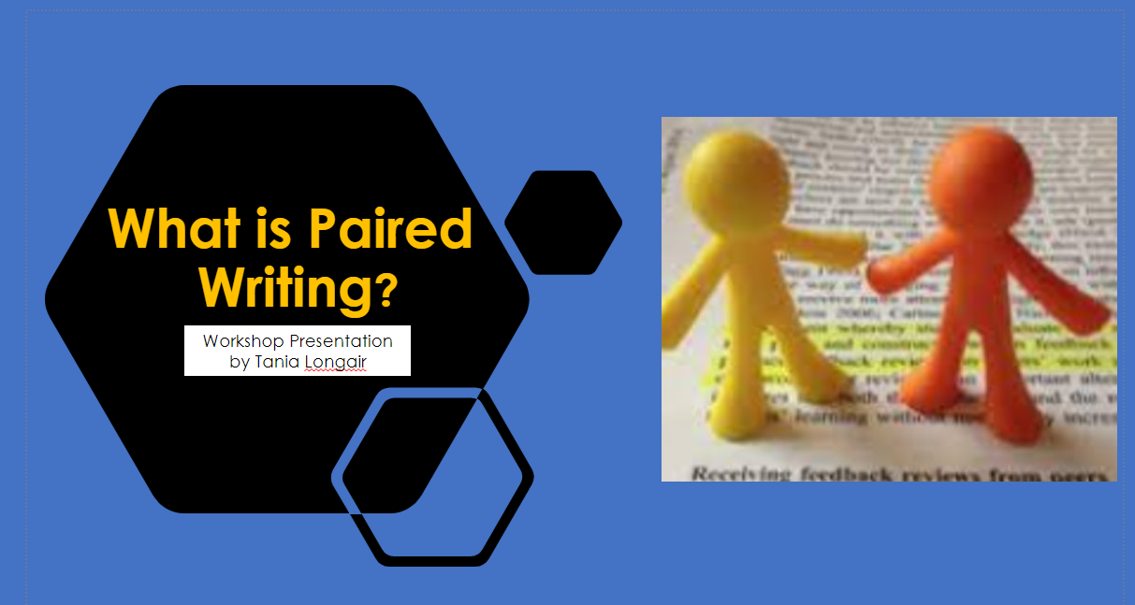

Summary of literature on Pair Writing and implications for practice (Prezi)
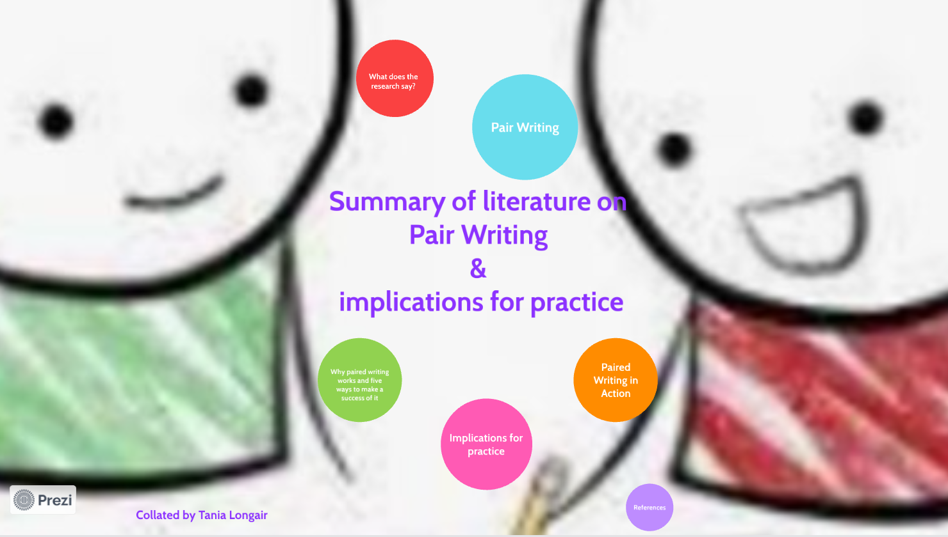
Reciprocal Teaching (Prezi)
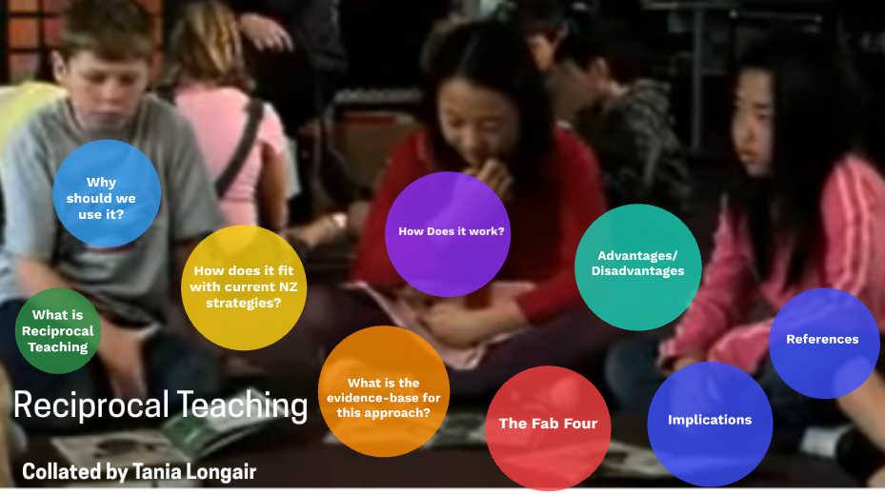
Additional resources
Kete of Māori Reources (Google Site)
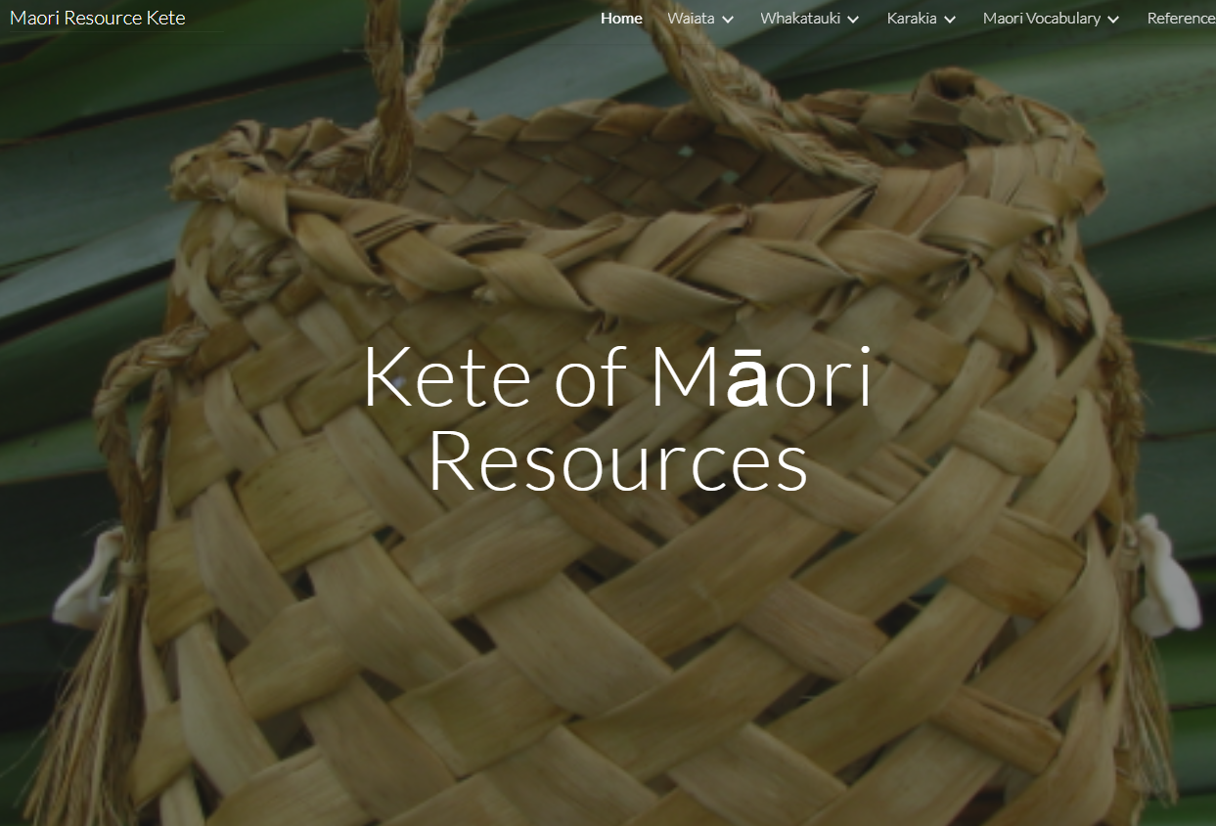
Evaluation Tool for Tātaiako
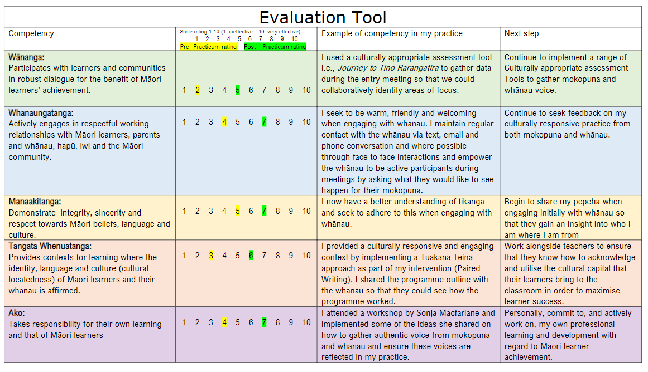
Ōtāhuhu (PowerPoint)
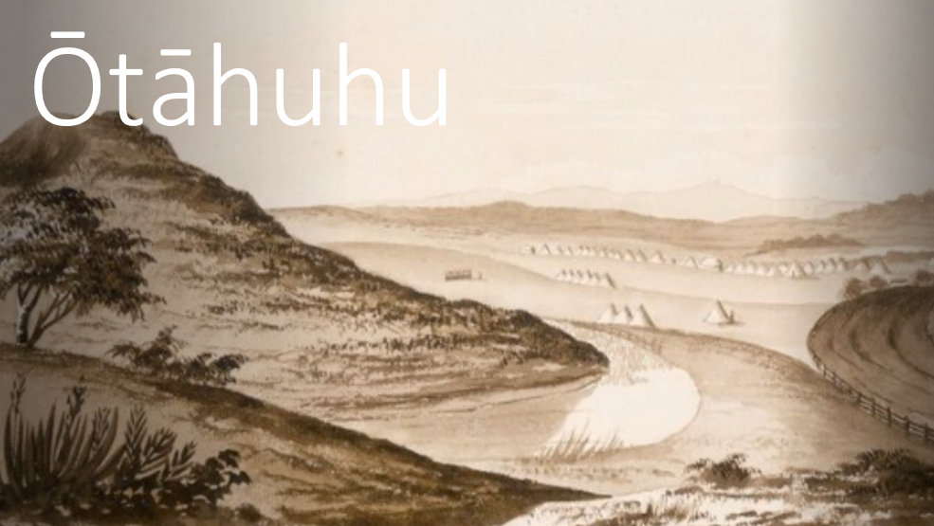
E-Kete of Culturally Appropriate Assessment Tools
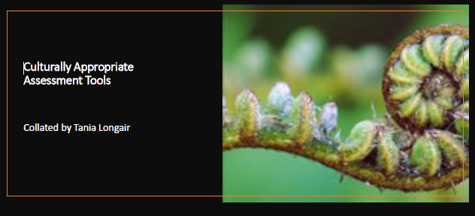

Belly Breathing – Tikanga Tips for Teachers
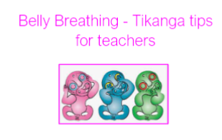
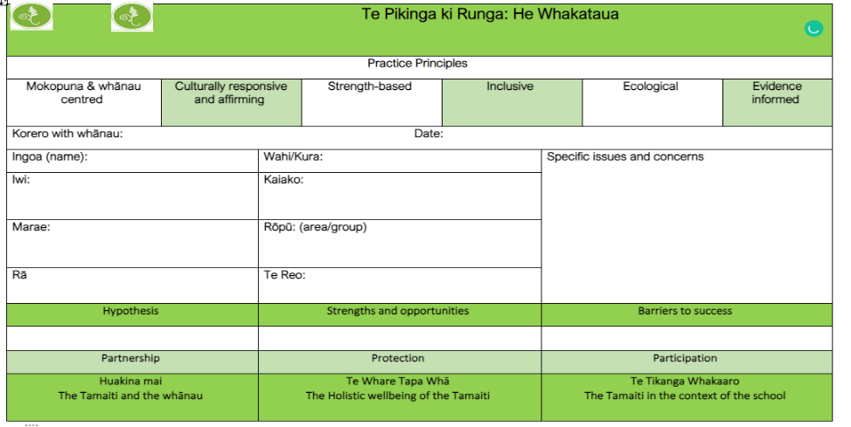
Te Pikinga ki Runga: He Whakataua (Template)
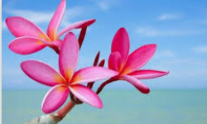
4.Pacific

Whakataukī
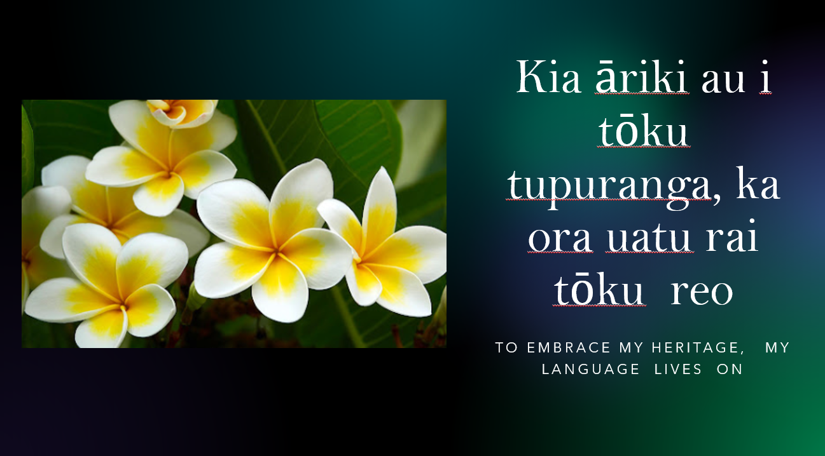
Videos/vimeos
Tapasā – a compass to navigate diversity
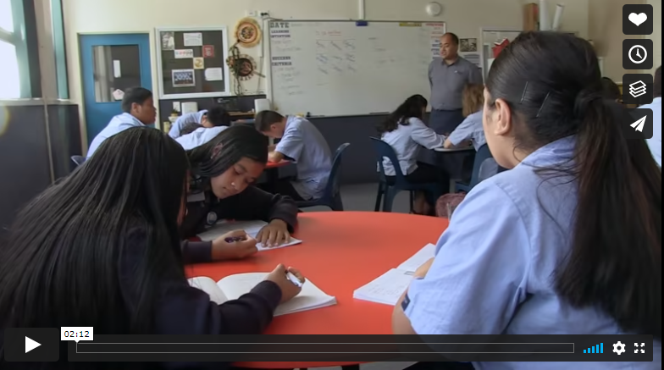

Cultural Diversity Spotlight (Google Slides Presentation)
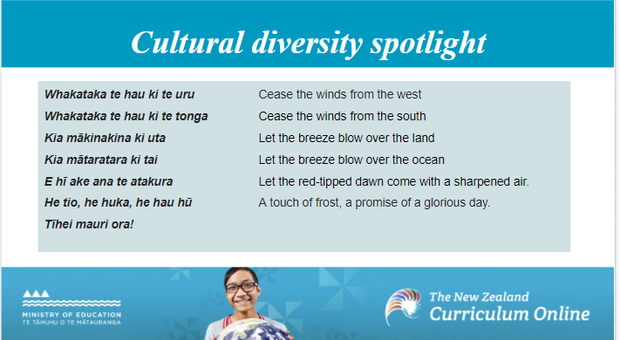

The cultural diversity curriculum principle(Vimeo)

Cultural Diversity in the Classoom(Vimeo)
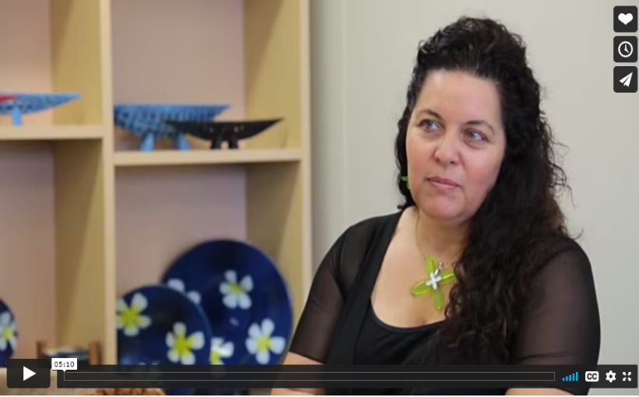

Cultural diversity and priority learners
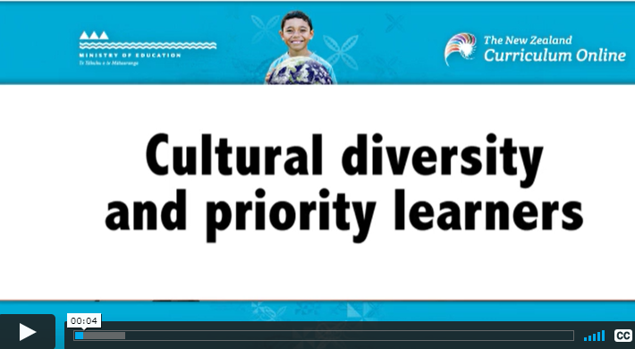

Who I am – The Importance of Culture(Vimeo)
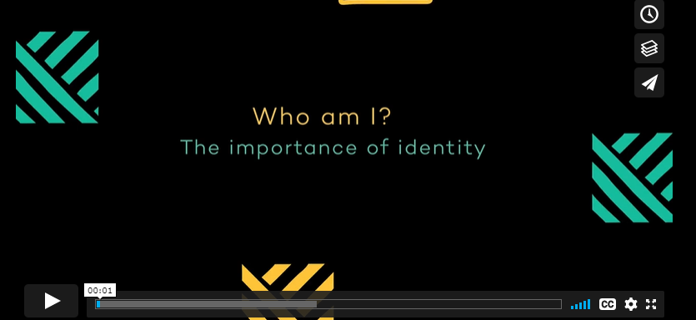

Colouring in the White Spaces: Dr Anne Milne (YouTube Clip)

Professor Colleen Ward - A Multicultural nation in a Bicultural context

What is culturally responsive teaching?(Understood Website)
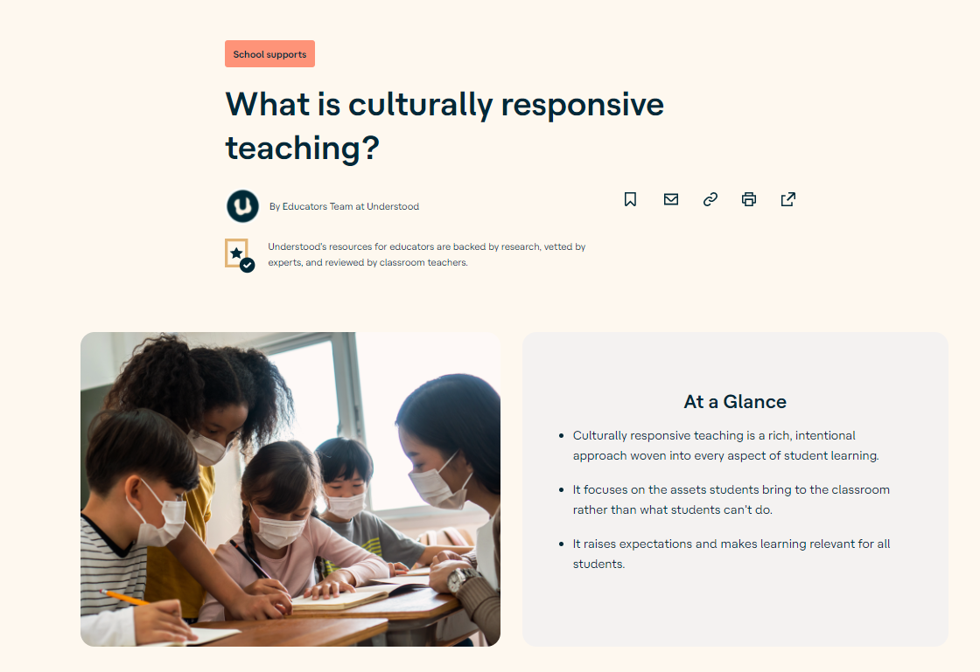
Articles/professional readings
The Rule of Law, BiCulturalism and Multiculturalism(Speech)

PowerPoints/Google slides
Culturally Responsive Teaching (E-Book)
Cultural Iceberg (Template)
Tuakana Teina - PowerPoint

Reflections on the Tuakana Teina Approach

Biculturalism and Multiculturalism (Powerpoint)
Tataiako & Tapasa Implications for Inclusive RTLB Practice

Summary of Culturally Responsive Pedagogy

Kete of Pacific Resources (Google Site)
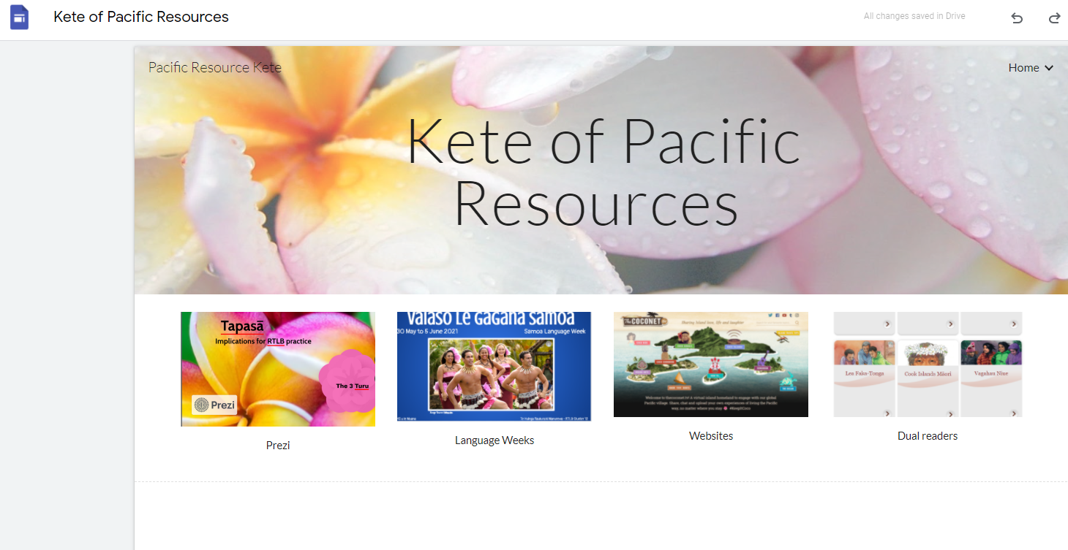
APPE Key Shift 3
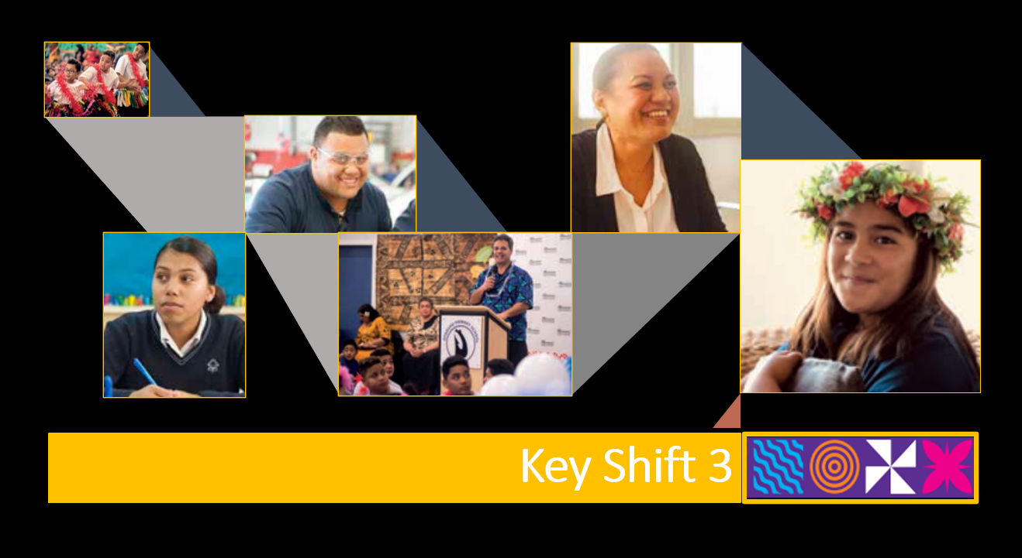

Tapasā: Implications for RTLB practice
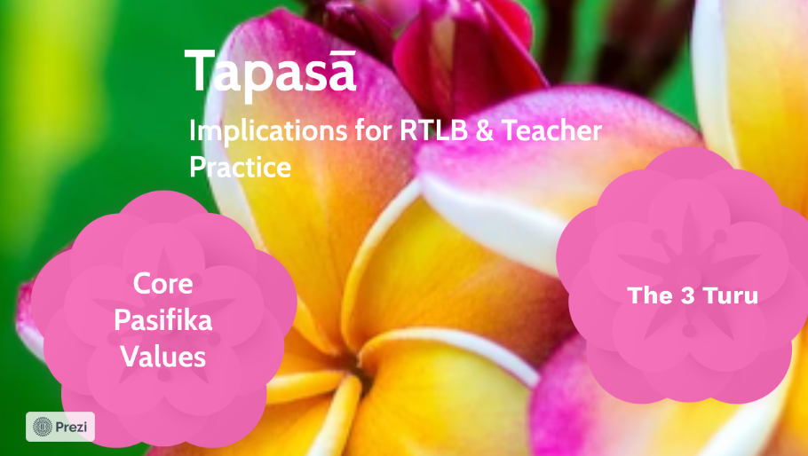
The Coconet TV Wesite
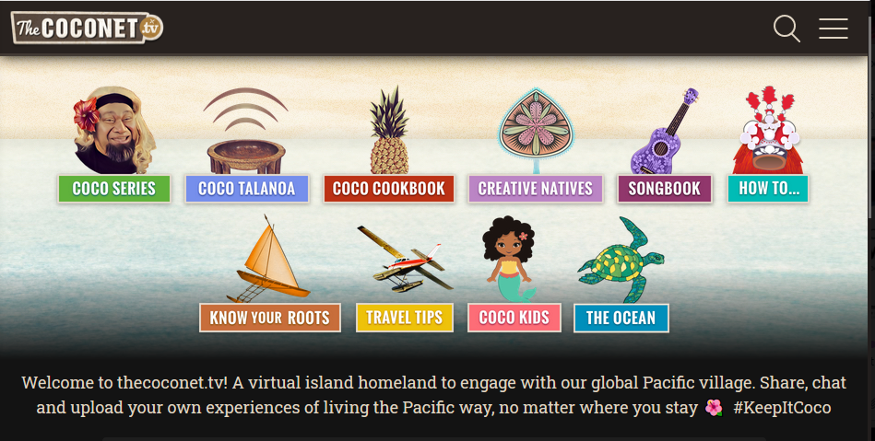
Pacific cultural competency: A values strength-based approach(Workbook for teachers)
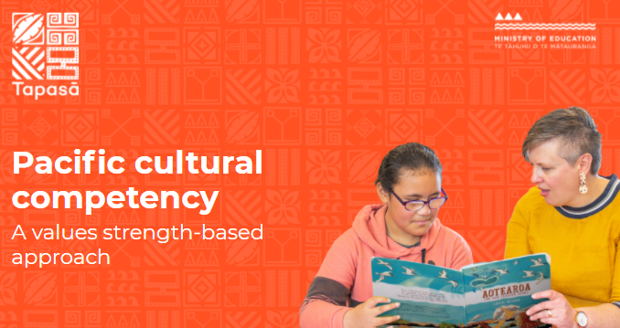

Culture Counts (SlideShare)
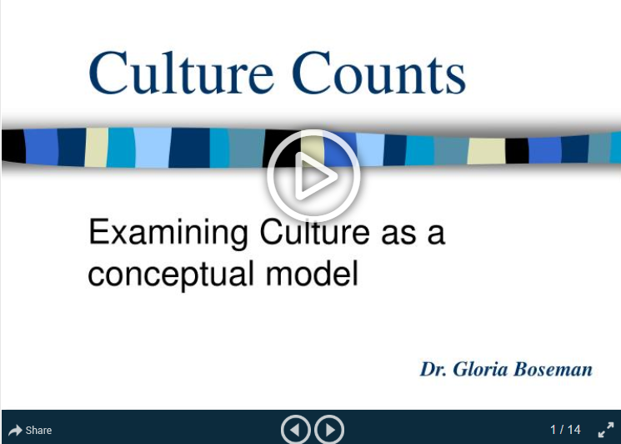
Unconscious Bias(PowerPoint)
Culture and Power(Prezi)

Mindful Reflection as a Process for Developing Culturally Responsive Practice

Subject specific resources
Literacy
Presentation on dual language readers.pptx
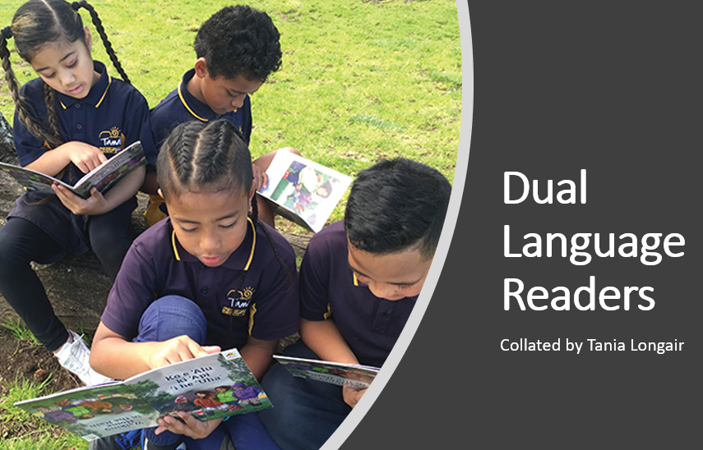
Peer Writing PowerPoint Workshop Presentation

Summary of literature on Pair Writing and implications for practice (Prezi)
Reciprocal Teaching (Prezi)
Math
Developing Mathematical Inquiry Communities (DMIC) – PowerPoint Presentation
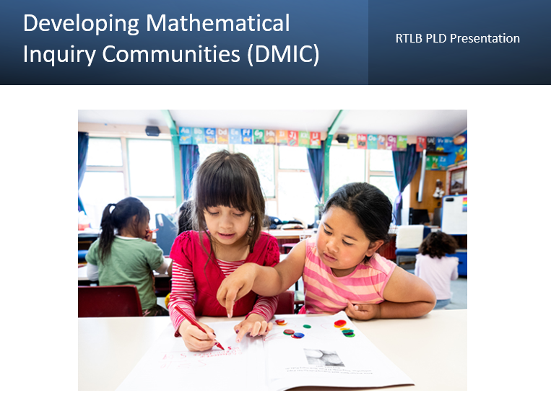
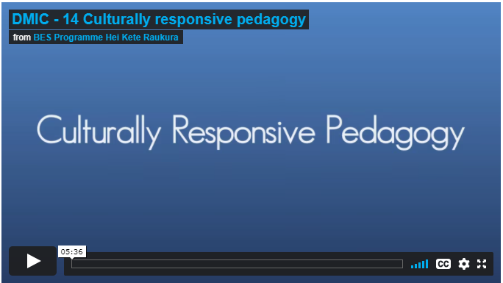
Culturally responsive Pedagogy - Developing Mathematical Communities of Inquiry

Additional resources
Cultural Diversity Checklist for Schools

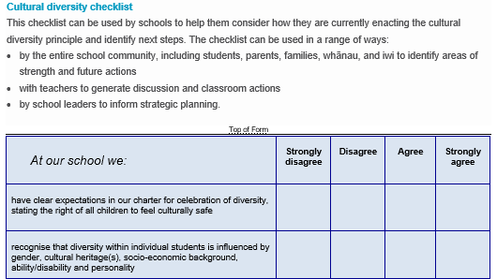
Tapasā Proverb Cards
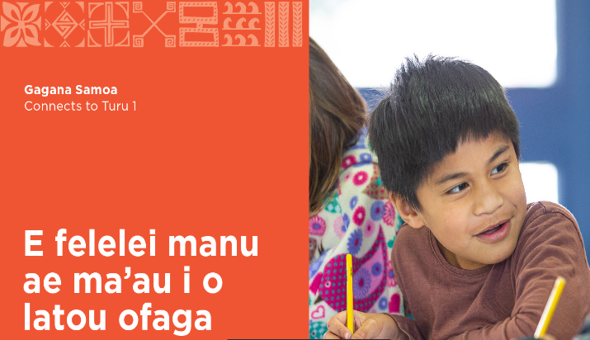

E-Kete of Culturally Appropriate Assessment Tools
5.Other Cultures
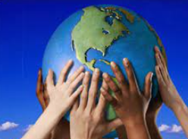
Whakataukī
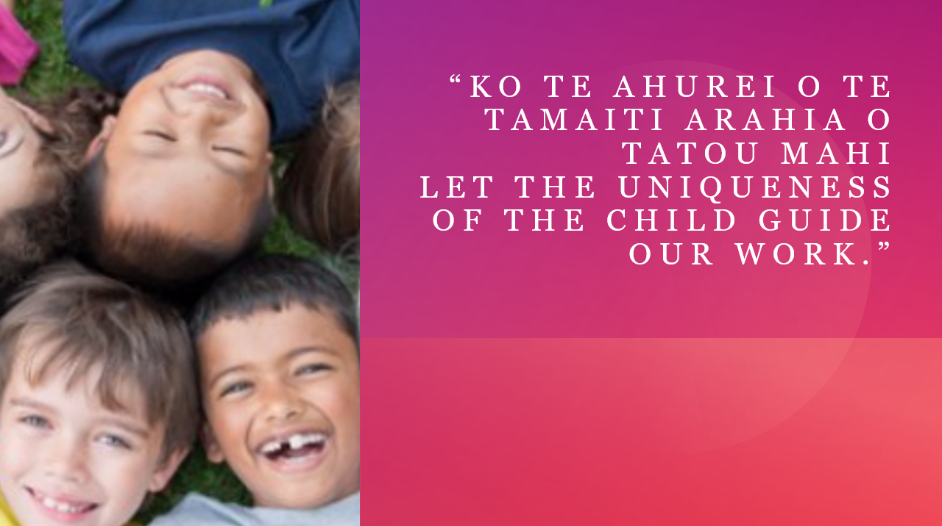
Videos/vimeos
Articles/professional readings
PowerPoints/Google slides
Subject Specific resources
Additional resources
Ā mātou kōrero – Our stories (developed to support, reflect, and celebrate the Kiwi Muslim community)
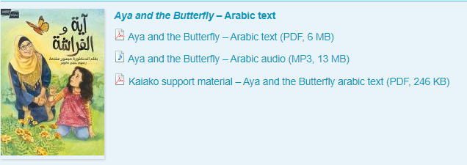
Islamic Practices Information (pdf)
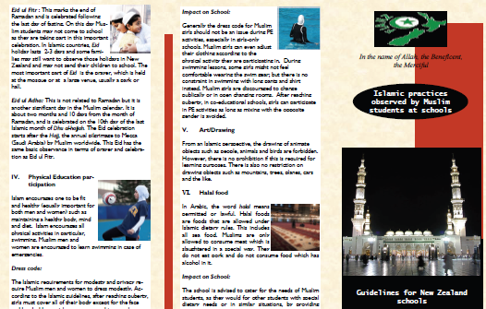

A Helpful Guide to Basic Muslim Etiquette(Pdf)
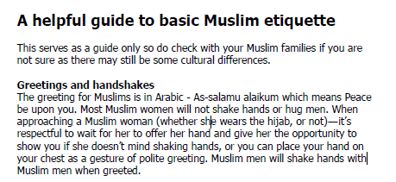

6.Spirituality
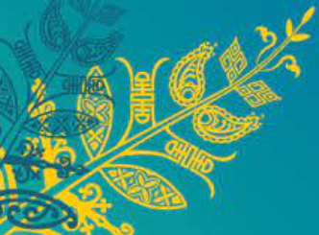

Whakataukī
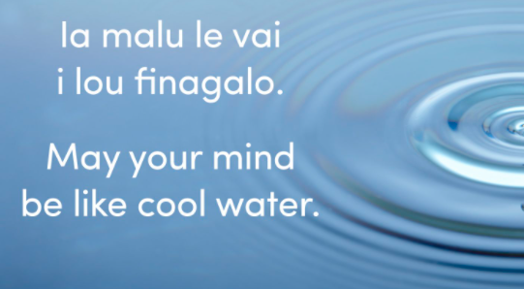

Ratana Faith
PowerPoints/Google slides
Ratana Faith PowerPoint
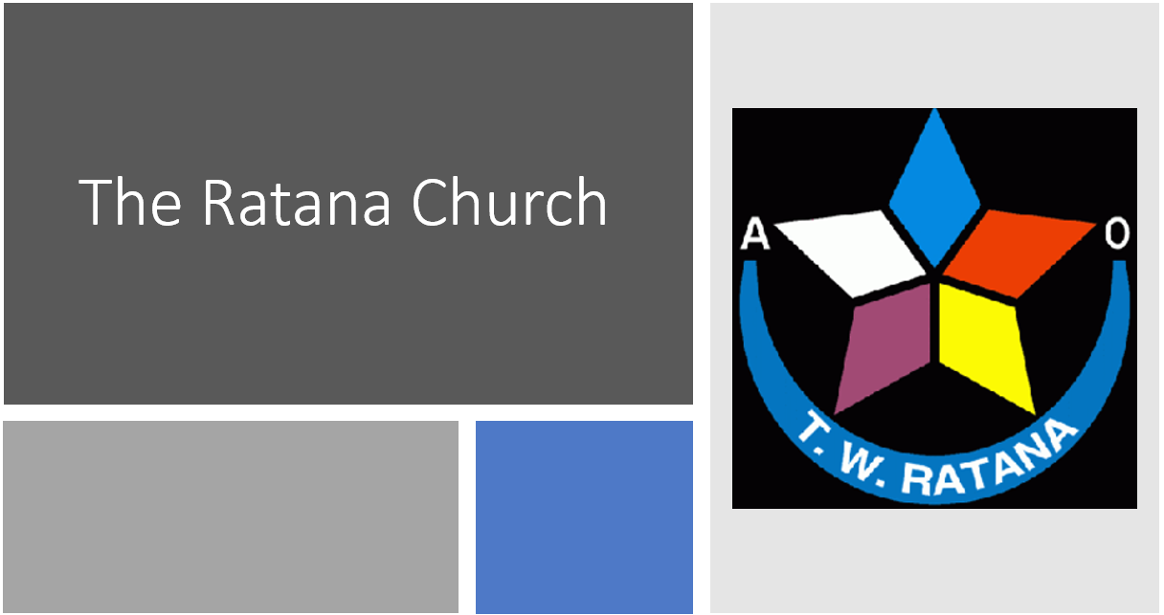
Additional resources

Catholic
PowerPoints/Google slides
Catholic PowerPoint
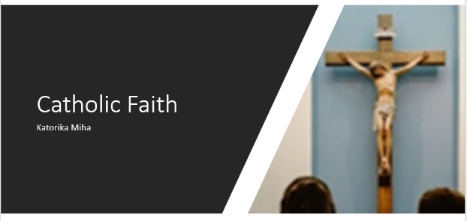
Additional resources

Seventh Day Adventist
PowerPoints/Google slides
Seventh-day Adventist Faith PowerPoint

Additional resources

7.Student Voice Tools

Learner Profile 1
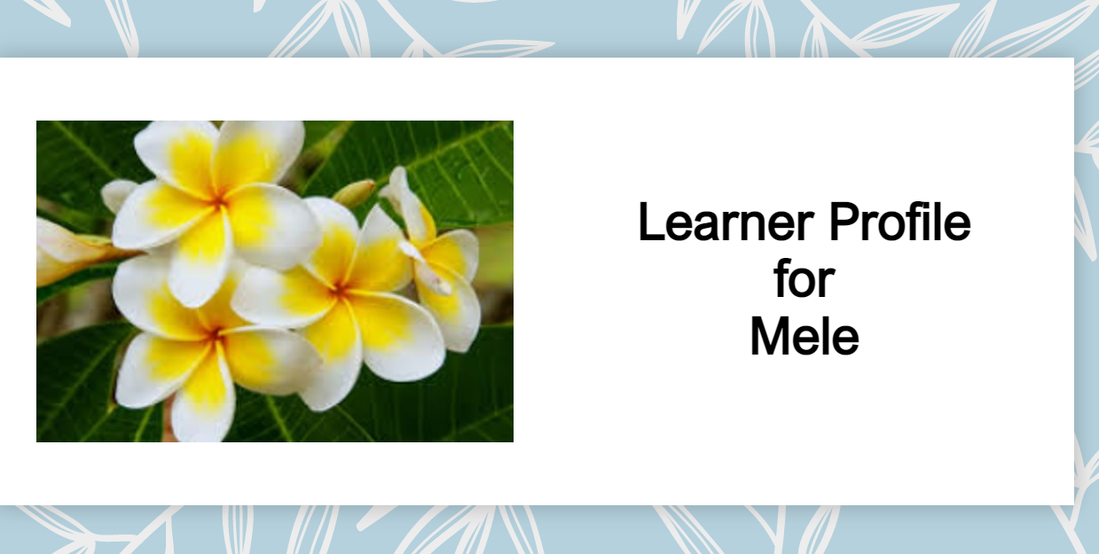
Learner Profile 2
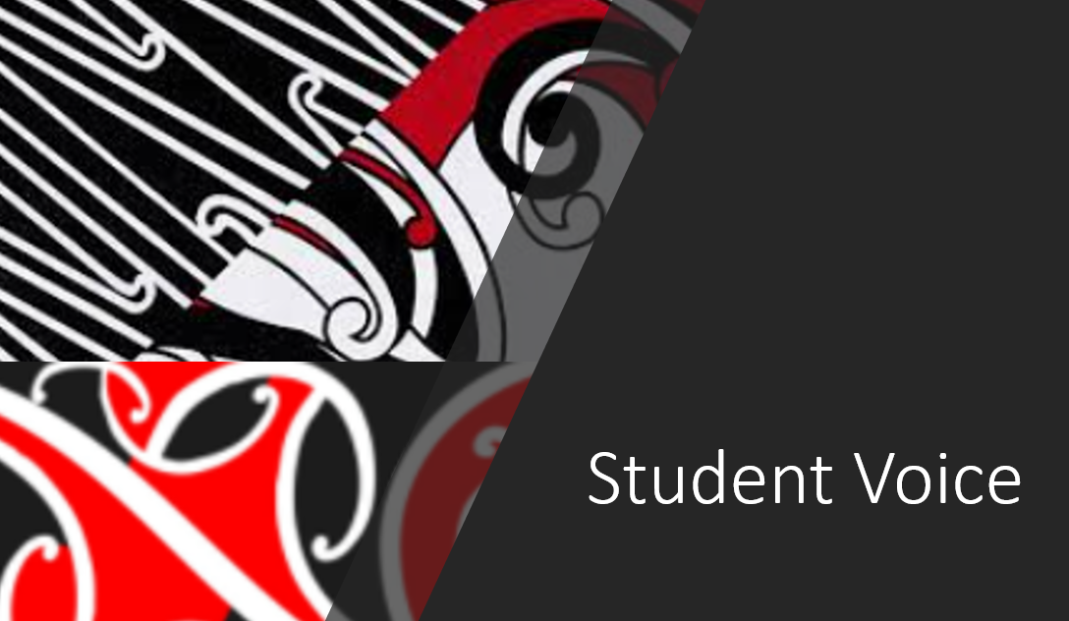
Learner Profile 3
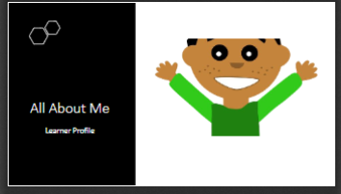

Learner Profile 4
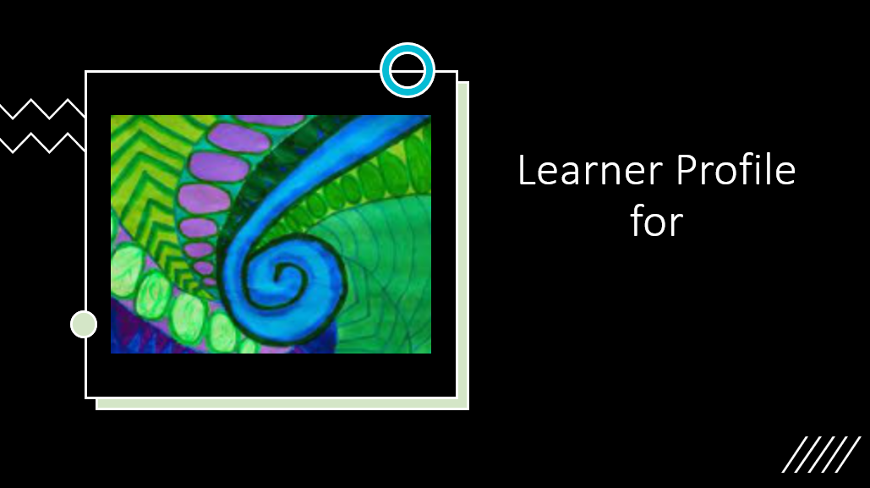

Fonofale (Template)
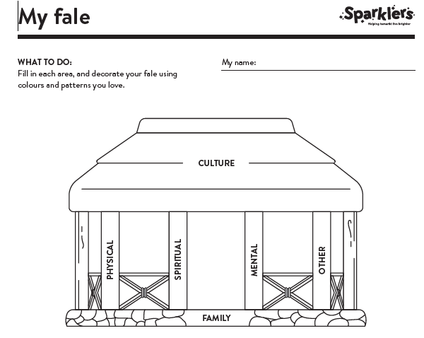

Te Whare Tapa Whā Template
